

### **2025 Corporate Partnership Package**

**Support of the Forum Provides:**

Outstanding Leadership Development Programs

Recognition for Your Support of Women’s Leadership Achievements

Opportunities for Business Development with Influential Participants

Promotion of Your Commitment to Diversity & Outreach Programs

Access to High-Profile National & International Leaders & Experts

Heightened Presence within the Community

**Major Partners Include:**

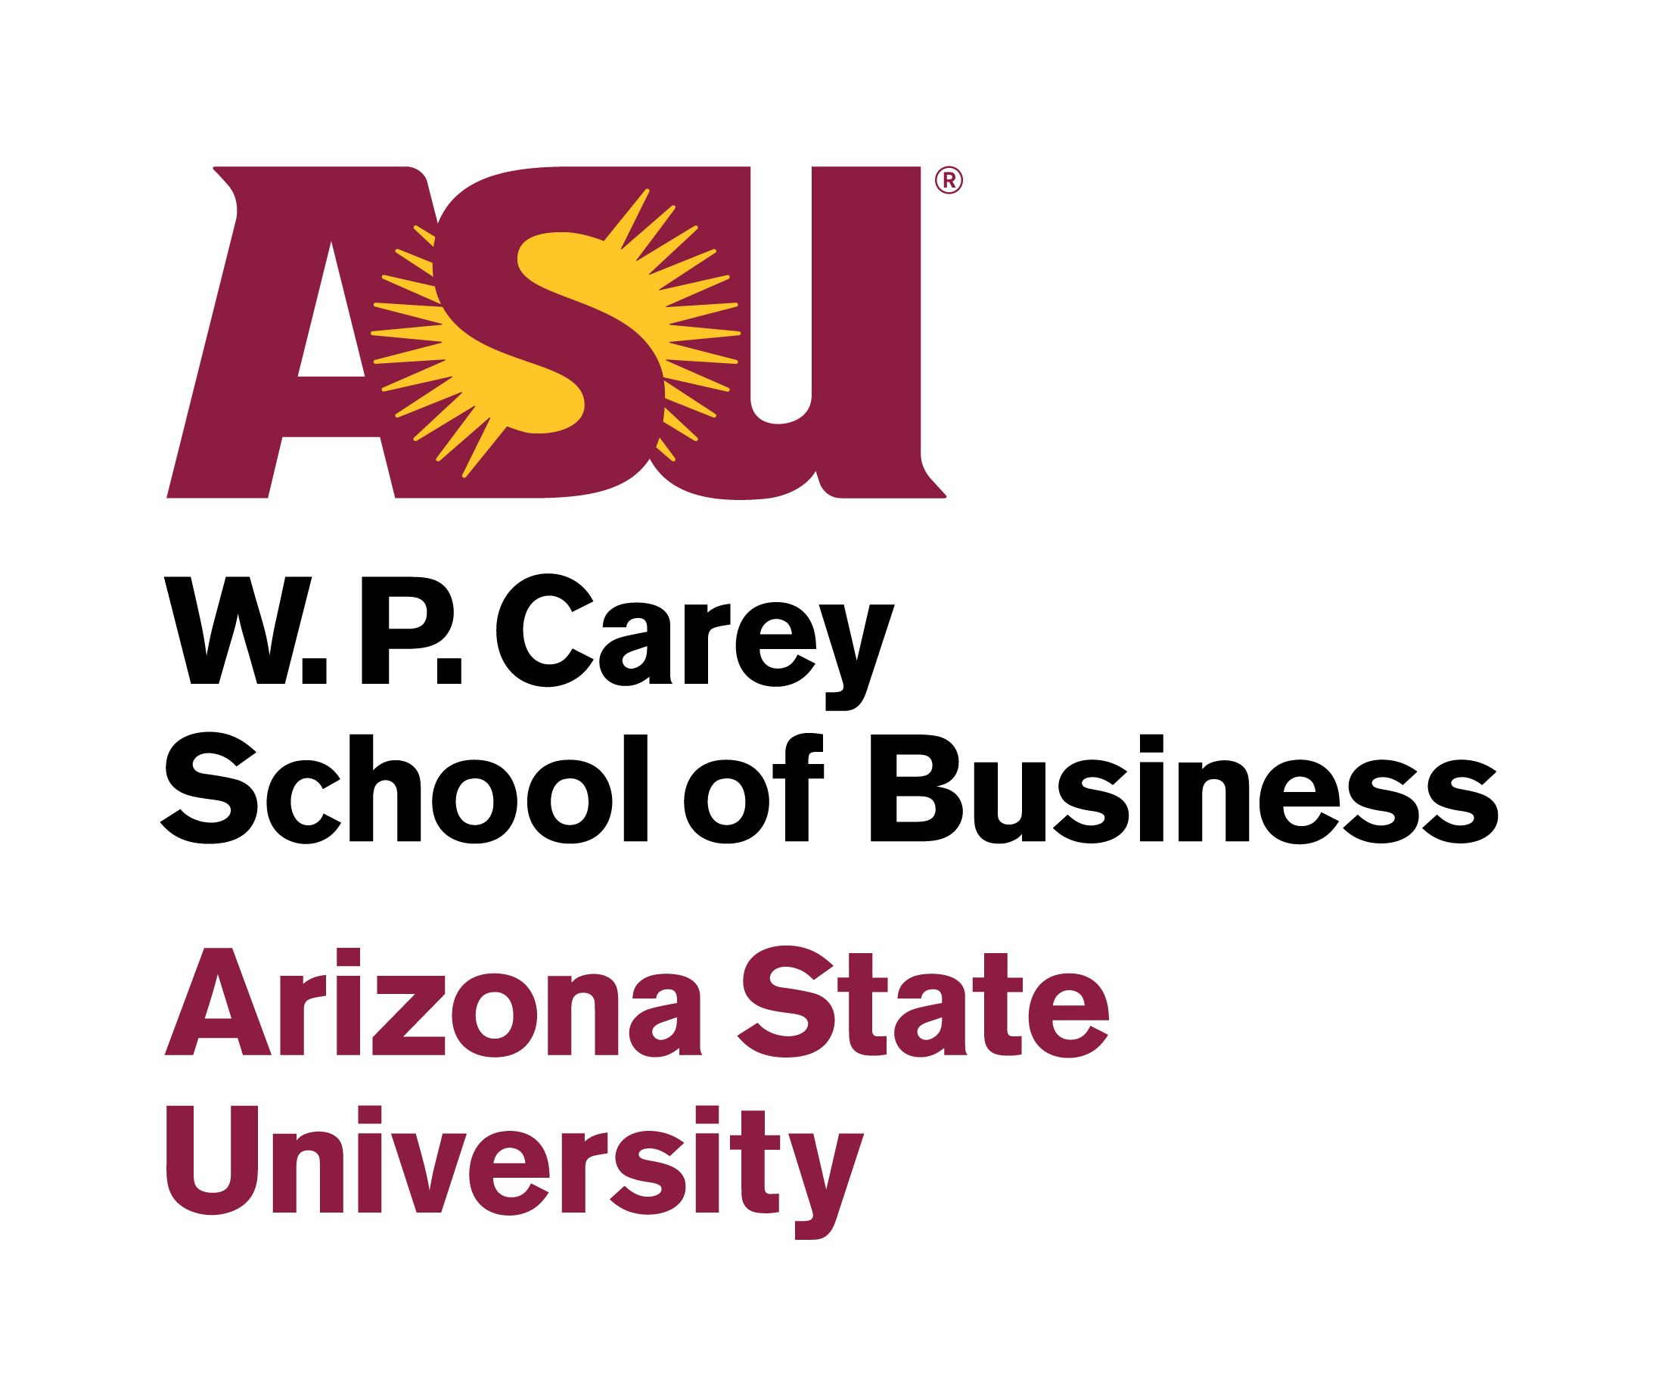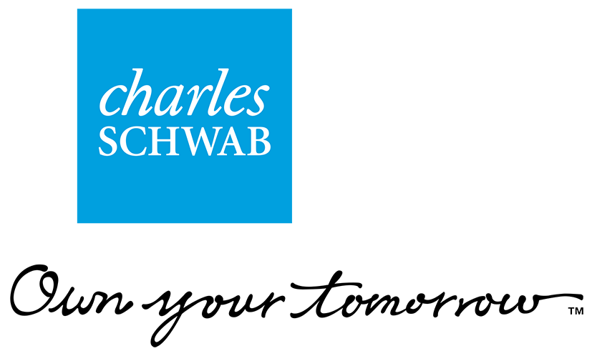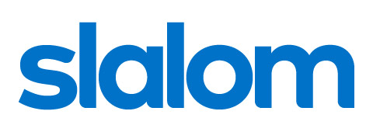

**2025 Corporate Partnership Opportunities**



**FORUM PARTNER ($25,000) (Limited Availability):**

Prominent recognition as Forum Partner in Forum, Symposium and "Conversation" publications

(Save-the-Date Announcements, Invitations, Programs, Leadership & Referral Guide*)

Opportunity to make speaker introduction at Symposium

Booth or display in prominent position at Symposium to highlight Partner’s products and services

Verbal recognition with Company description at Symposium (Opening/Luncheon/Closing) and at "Conversation" events

Membership on Forum Executive Board (with involvement in strategic aspects of Forum planning)

Recognition as Forum Partner on Forum website, with linkage to partner website

Prominent recognition as Forum Partner in Forum advertising

Prominent recognition as Forum Partner on Symposium and “Conversation” events signage

(including large-screen signage and corporate banners at Symposium)

Prominent recognition as Forum Partner in media materials, including press releases and other media outreach

Focus on Partner in Leadership & Referral Guide*, on Inside Cover and/or Divider Page

Full-page Ad & Full-page Listing in *The Business Directory* in Leadership & Referral Guide

Attendance for 20+ to the Symposium, with reserved Corporate Tables and signage at Symposium Luncheon and Keynotes

Attendance for two (2) at pre-Symposium Dinner or Cocktail Party with speakers (subject to speaker availability)

Attendance for two (2) and Additional Priority Invitations** to "Conversation" Events

Attendance for two (2) to pre- or post-reception at all "Conversation" events (subject to speaker availability)

Ability to advertise Partner's participation in Forum in corporate materials (as Partner deems desirable)

**Additional/Substitute Benefits as determined by Partner and Forum**

**LEAD PARTNER ($15,000) (Limited Availability):**

Recognition as Lead Partner in Symposium and "Conversation" publications

(Save-the-Date Announcements, Invitations, Programs, Leadership & Referral Guide*)

Opportunity to make speaker introduction at Symposium

Opportunity to display materials at Symposium to highlight Partner’s products and services

Verbal recognition with Company description at Symposium (Opening/ Luncheon/Closing) and at "Conversation" events

Membership on Forum Executive Board (with involvement in strategic aspects of Forum planning)

Recognition as Lead Partner on Forum website, with linkage to partner website

Recognition as Lead Partner in Forum advertising

Recognition as Lead Partner on Symposium and “Conversation” events signage

(including large-screen signage and corporate banner at Symposium)

Recognition as Lead Partner in media materials, including press releases and other media outreach

Full-page Ad & Full-page Listing in *The Business Directory* in Leadership & Referral Guide

Attendance for 20 to the Symposium, with preferred location corporate tables and signage at Symposium Luncheon

Attendance for one (1) at pre-Symposium Dinner or Cocktail Party with speakers (subject to speaker availability)

Priority Invitations** to "Conversation" Events

Attendance for one (1) to pre- or post-reception at all "Conversation" events (subject to speaker availability)

Ability to advertise Partner's participation in Forum in corporate materials (as Partner deems desirable)

**PLATINUM PARTNER ($7,500) (Limited Availability):**

Recognition as Platinum Partner in Symposium and "Conversation" publications

Recognition as Platinum Partner on Forum website, with linkage to partner website

Recognition in Symposium advertising

Membership on Forum Executive Board (with involvement in strategic aspects of Forum planning)

Sponsorship of General Session or Co-Sponsorship of Afternoon Reception at Symposium

Verbal recognition, with company/firm description, at sponsored event at Symposium

Corporate name/image on signage displayed at sponsored event and recognition on general signage

Full-page Ad & Full-column Listing in *The Business Directory* in Leadership & Referral Guide*

Attendance for 10 to the Symposium and Corporate Table, with preferred location & signage, at Symposium luncheon

Priority Invitations** to "Conversation" Events

Attendance for one (1) to pre- or post-reception at all "Conversation" events (subject to speaker availability)

**GOLD PARTNER ($6,000) (Limited Availability):**

Recognition as Gold Partner in Program and Leadership & Referral Guide* and on certain Invitations

Recognition as Gold Partner on Forum website, with linkage to partner website

Sole Sponsorship of Concurrent Session at Symposium of Co-Sponsorship of Continental Breakfast at Symposium, with verbal recognition

Corporate name/image on signage displayed at sponsored event and recognition on general signage

Full-page Ad *The Business Directory* in Leadership & Referral Guide

Attendance for 10 to the Symposium and Corporate Table at Symposium luncheon

Priority Invitations** to “Conversation" Events

**SILVER PARTNER ($2,500):**

Recognition as Silver Partner on Symposium Program and Leadership & Referral Guide*

Recognition as Silver Partner on Forum website, with linkage to partner website

Corporate name/image on general signage

Full-column listing in *The Business Directory* in Leadership & Referral Guide

Attendance for two (2) to the Symposium

Priority Invitations** to "Conversation" Events

**COPPER PARTNER ($1,000):**

Recognition in Symposium Program

Full-Column listing *The Business Directory* in Leadership & Referral Guide*

Recognition on signage at Symposium

Attendance for 1 to the Symposium

Priority Invitations** to “Conversation” Events

* The Forum’s Leadership & Referral Guide is provided to all attendees at the Symposium.

** “Invitation” does not include costs associated with attendance; “Attendance” does include such costs.

**Becoming Involved/Forum Information**

The Forum is made possible through the support and involvement of organizations and individuals who are committed to the advancement of women in leadership. Additional information is available at [www.azleadersforum.com](http://www.azleadersforum.com). Or feel free to contact us at [anne@azleadersforum.com](mailto:anne@azleadersforum.com) or at 602-861-9350. We welcome your inquiries and your involvement.