2021 Table Purchase
Provides Attendance for 10 Individuals,
Invitations to Special AWLF Events &
Recognition for Your Support of Women's Leadership hievements

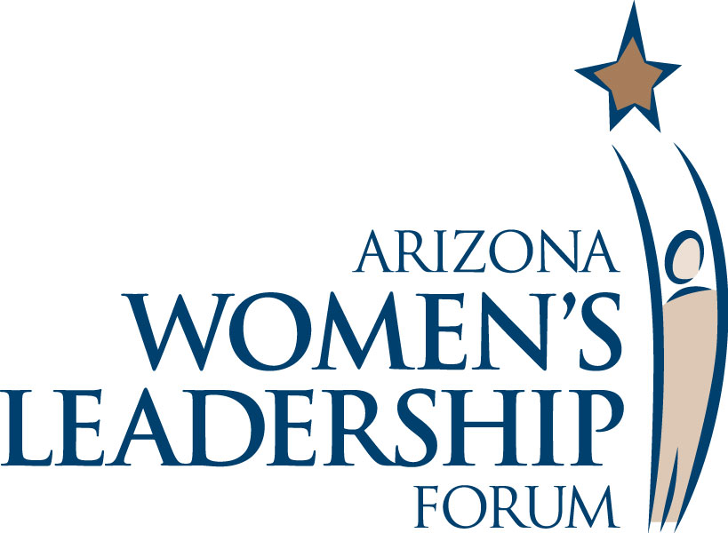

Preferred Table Purchase Includes:

Attendance for 10 Individuals to the 2021 Symposium
A full-day conference, including Breakfast, Luncheon & Reception.
Also includes AWLF’s Leadership & Referral Guide for each participant.
Reserved Table, in Preferred Location, at Symposium Luncheon
Recognition as Gold Partner: Logo on Symposium Screen Signage & on Forum website, with linkage to partner website, Name or Logo in Symposium Program & in Leadership & Referral Guide
Recognition as Table Sponsor in Symposium Program and on Signage at Luncheon Table
Full-Page Ad/Listing in The Business Directory in Leadership & Referral Guide
Priority, Guaranteed Invitation(s)* to Conversation Events

Preferred Table Purchase In Advance: $4,000

Full Price: $5,000

Basic Table & Half-Table Purchase Includes:

Attendance for 10 Individuals to the 2021 Symposium with Full-Table Purchase
Attendance for 5 Individuals to the 2021 Symposium with Half-Table Purchase
A full-day conference, including Breakfast, Luncheon & Reception.
Also includes AWLF’s Leadership & Referral Guide for each participant.
Reserved Table at Symposium Luncheon
Recognition as Table Sponsor in Symposium Program and on Signage at Luncheon Table
Full-Column Ad/Listing in The Business Directory in Leadership & Referral Guide

Advance Basic Table Purchase In Advance: $3,500

Advance Basic Half-Table Purchase In Advance: $1,750

Full Price: $4,000 for Full table; $2,000 for Half-Table

* “Invitation” does not include costs associated with attendance; “Attendance” does include such costs.

Website: www.azleadersforum.com
Contact Information: anne@azleadersforum.com or 602-861-9350

Major Partners Include

