2021 Corporate Partnership Package

Support of the Forum Provides:

Outstanding Leadership Development Programs

Recognition for Your Support of Women’s Leadership Achievements

Opportunities for Business Development with Influential Participants

Promotion of Your Commitment to Diversity & Outreach Programs

Access to High-Profile National & International Leaders & Experts

Heightened Presence within the Community

Major Partners Include:

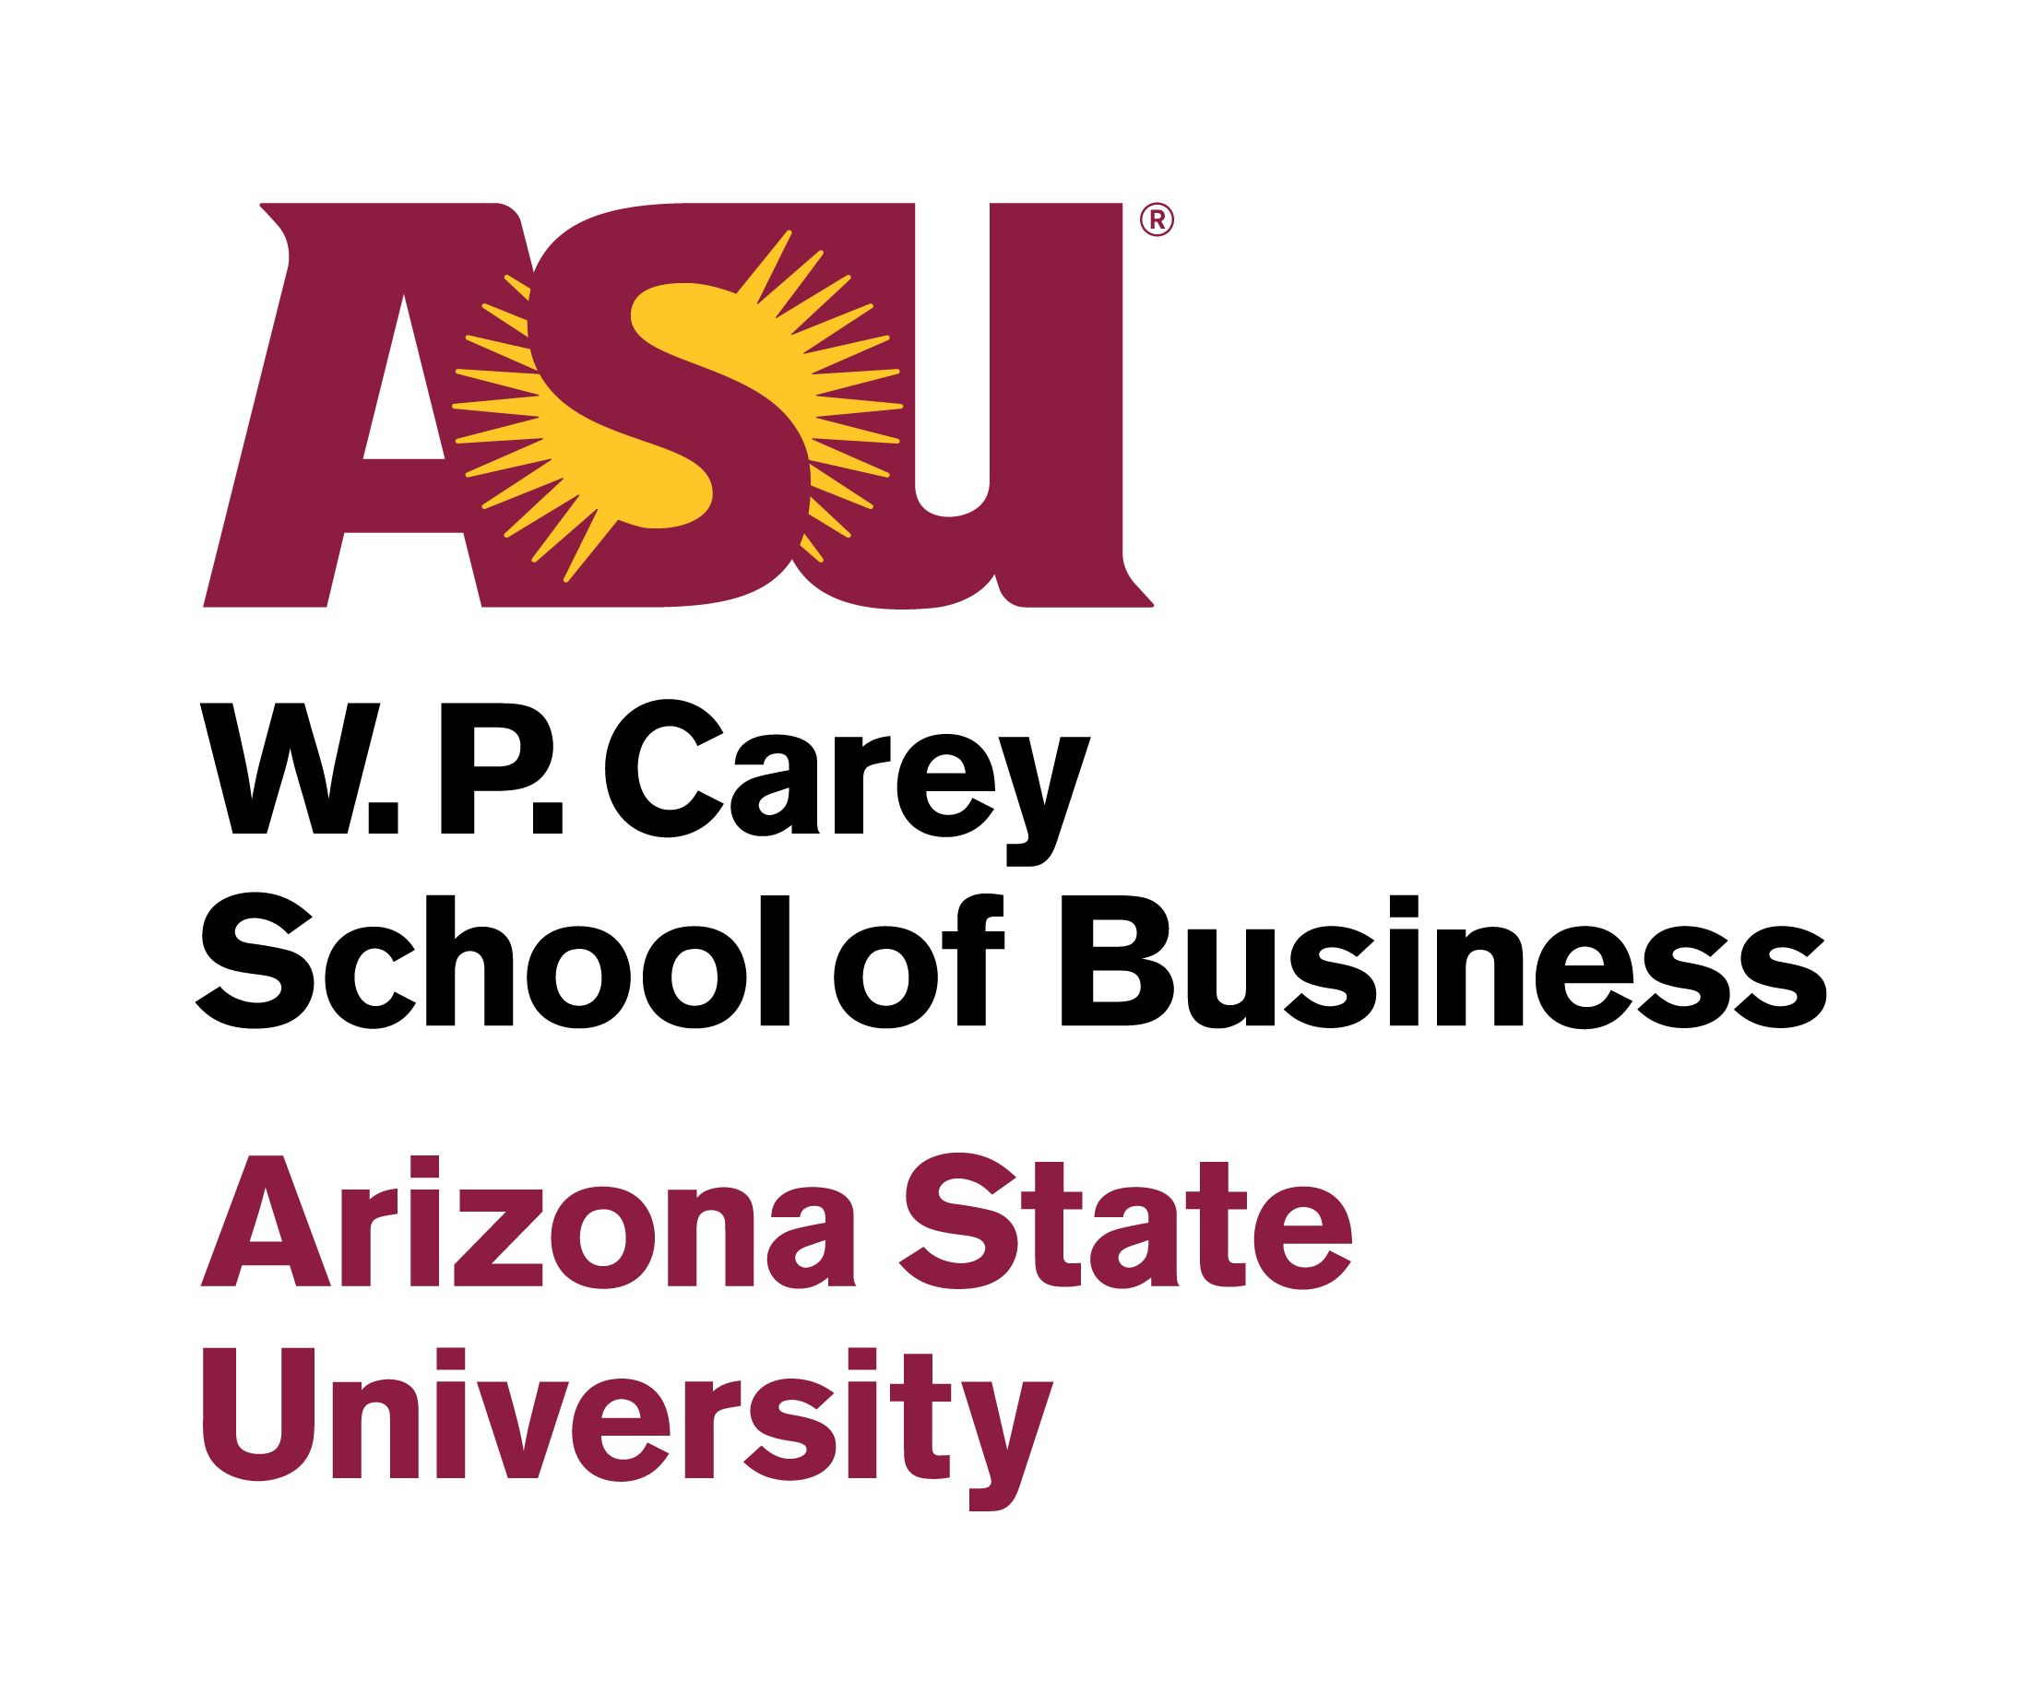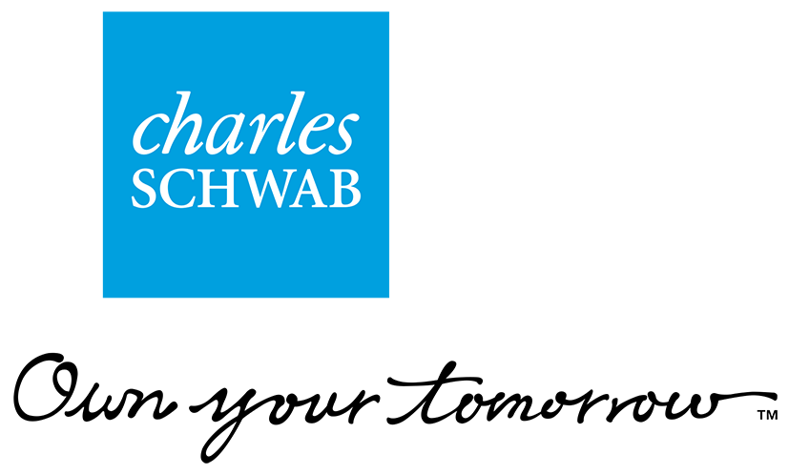

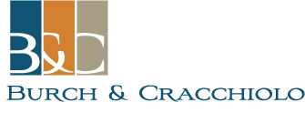

2021 Corporate Partnership Opportunities

FORUM LEADERSHIP PARTNER ($50,000) (Limited Availability):
Primary, prominent recognition as Forum Leadership Partner in all Forum, Symposium and "Conversation" publications
(Save-the-Date Announcements, Invitations, Programs, Leadership & Referral Guide*)
Opportunity for Partner executive to highlight commitment to diversity/women’s leadership from the podium at Symposium
Consideration as panelist or panel moderator at Symposium, or Opportunity to make speaker introduction at Symposium
Booth or display in prominent position at Symposium (staffed, if desired) to highlight Partner’s products and services
Verbal recognition with Company description at Symposium (Opening/Luncheon/Closing) and at "Conversation" events
Membership on Forum Executive Board (with involvement in strategic aspects of Forum planning)
Primary, prominent recognition as Forum Leadership Partner on Forum website, with linkage to partner website
Primary, prominent recognition as Forum Leadership Partner in all Forum advertising
Primary, prominent recognition as Forum Leadership Partner on Symposium and “Conversation” events signage
(including large-screen signage, podium signage and corporate banner at Symposium)
Primary, prominent recognition as Forum Leadership Partner in media materials, inc. press releases and other media outreach
Prominent focus on Partner in Leadership & Referral Guide, on Inside Cover, Divider Page and/or insert
Full-page Ad & Full-page Listing in print version of The Business Directory in Leadership & Referral Guide
Attendance for 30 to the Symposium, with reserved Corporate Tables and signage, at Symposium Luncheon and Keynotes
Attendance for two (2) at pre-Symposium dinner with speakers (subject to speaker availability)
Attendance for four (4) to "Conversation" Events
Attendance for two (2) to pre- or post-reception at all "Conversation" events (subject to speaker availability)
Ability to advertise Partner's participation in Forum in corporate materials (as Partner deems desirable)
Additional/Substitute Benefits as determined by Partner and Forum

FORUM PARTNER ($25,000) (Limited Availability):
Prominent recognition as Forum Partner in all Forum, Symposium and "Conversation" publications
(Save-the-Date Announcements, Invitations, Programs, Leadership & Referral Guide*)
Opportunity to make speaker introduction at Symposium
Booth or display in prominent position at Symposium to highlight Partner’s products and services
Verbal recognition with Company description at Symposium (Opening/Luncheon/Closing) and at "Conversation" events
Membership on Forum Executive Board (with involvement in strategic aspects of Forum planning)
Recognition as Forum Partner on Forum website, with linkage to partner website
Prominent recognition as Forum Partner in all Forum advertising
Prominent recognition as Forum Partner on Symposium and “Conversation” events signage
(including large-screen signage, podium signage and corporate banner at Symposium)
Prominent recognition as Forum Partner in media materials, including press releases and other media outreach
Focus on Partner in Leadership & Referral Guide*, on Inside Cover and/or Divider Page
Full-page Ad & Full-page Listing in print version of The Business Directory in Leadership & Referral Guide
Attendance for 20 to the Symposium, with reserved Corporate Tables and signage at Symposium Luncheon and Keynotes
Attendance for two (2) at pre-Symposium dinner with speakers (subject to speaker availability)
Attendance for two (2) to "Conversation" Events
Attendance for two (2) to pre- or post-reception at all "Conversation" events (subject to speaker availability)
Ability to advertise Partner's participation in Forum in corporate materials (as Partner deems desirable)
Additional/Substitute Benefits as determined by Partner and Forum

LEAD PARTNERS ($15,000) (Limited Availability):
Recognition as Lead Partner in all Symposium and "Conversation" publications
(Save-the-Date Announcements, Invitations, Programs, Leadership & Referral Guide*)
Opportunity to make speaker introduction at Symposium
Opportunity to display materials at Symposium to highlight Partner’s products and services
Verbal recognition with Company description at Symposium (Opening/ Luncheon/Closing) and at "Conversation" events
Membership on Forum Executive Board (with involvement in strategic aspects of Forum planning)
Recognition as Lead Partner on Forum website, with linkage to partner website
Recognition as Lead Partner in all Forum advertising
Recognition as Lead Partner on Symposium and “Conversation” events signage
(including large-screen signage, podium signage and corporate banner at Symposium)
Recognition as Lead Partner in media materials, including press releases and other media outreach
Full-page Ad & Full-page Listing in print version of The Business Directory in Leadership & Referral Guide
Attendance for 20 to the Symposium, with preferred location corporate tables and signage at Symposium Luncheon
Attendance for one (1) at pre-Symposium dinner with speakers (subject to speaker availability)
Priority, Guaranteed Invitations** to "Conversation" Events
Attendance for one (1) to pre- or post-reception at all "Conversation" events (subject to speaker availability)
Ability to advertise Partner's participation in Forum in corporate materials (as Partner deems desirable)

PLATINUM PARTNERS ($7,500) (Limited Availability):
Recognition as Platinum Partner in Symposium and "Conversation" publications
Recognition as Platinum Partner on Forum website, with linkage to partner website
Recognition in all Symposium advertising
Membership on Forum Executive Board (with involvement in strategic aspects of Forum planning)
Sponsorship of General Session or Afternoon Reception at Symposium
Verbal recognition, with company/firm description, at sponsored event at Symposium
Corporate name/image on signage displayed at sponsored event and recognition on general signage
Full-page Ad & Full-column Listing in print version of The Business Directory in Leadership & Referral Guide*
Attendance for 10 to the Symposium and Corporate Table, with preferred location & signage, at Symposium luncheon
Priority, Guaranteed Invitations** to "Conversation" Events
Attendance for one (1) to pre- or post-reception at all "Conversation" events (subject to speaker availability)

GOLD EVENT PARTNERS ($6,000) (Limited Availability):
Recognition as Gold Event Partner in Program and Leadership & Referral Guide* and on certain Invitations
Recognition as Gold Event Partner on Forum website, with linkage to partner website
Sponsorship of Continental Breakfast or Concurrent Session at Symposium, with verbal recognition
Corporate name/image on signage displayed at sponsored event and recognition on general signage
Full-page Ad in print version of The Business Directory in Leadership & Referral Guide
Attendance for 10 to the Symposium and Corporate Table at Symposium luncheon
Priority, Guaranteed Invitations** to “Conversation" Events

GOLD PARTNERS ($2,500):
Recognition as Gold Partner on Symposium Program and Leadership & Referral Guide*
Recognition as Gold Partner on Forum website, with linkage to partner website
Corporate name/image on general signage
Full-column listing in print version of The Business Directory in Leadership & Referral Guide
Attendance for two (2) to the Symposium
Priority, Guaranteed Invitations** to "Conversation" Events

SILVER PARTNERS ($1,000):

Recognition in Symposium Program
Full-Column listing in print version of The Business Directory in Leadership & Referral Guide*
Recognition on signage at Symposium
Attendance for 1 to the Symposium

COPPER PARTNERS ($500):

Recognition in Symposium Program
1/2-Column listing in print version of The Business Directory in Leadership & Referral Guide*
Recognition on signage at Symposium

* The Forum’s Leadership & Referral Guide is distributed at the Symposium and at the “Conversation” events.
** “Invitation” does not include costs associated with attendance; “Attendance” does include such costs.

Becoming Involved/Forum Information

The Forum is made possible through the support and involvement of organizations and individuals who are committed to the advancement of women in leadership. Additional information is available at www.azleadersforum.com. Or feel free to contact us at anne@azleadersforum.com or at 602-861-9350. We welcome your inquiries and your involvement.

